
QUALITY ALERT

Customer: ChamClad Date: Nov 22, 2024
Die: 15750 Customer NCR:
Type of Complaint: ChamClad REJECTED

Description: ChamClad REJECTED due to wall thickness being small, break under force.

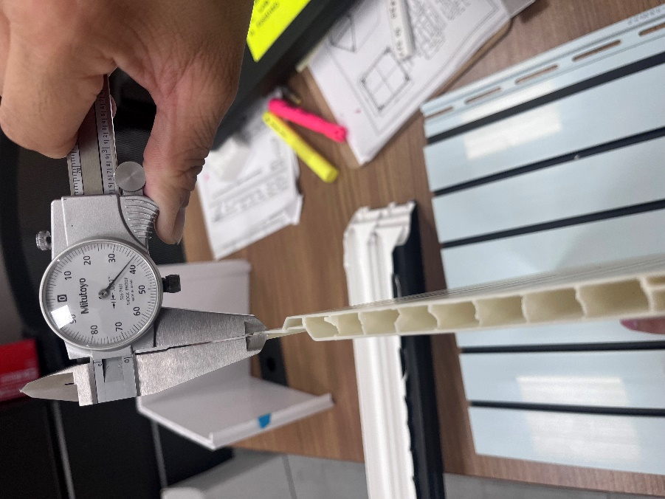
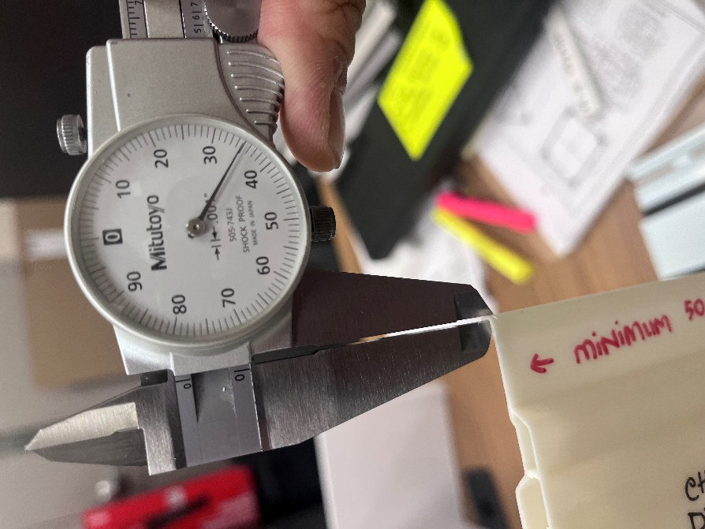

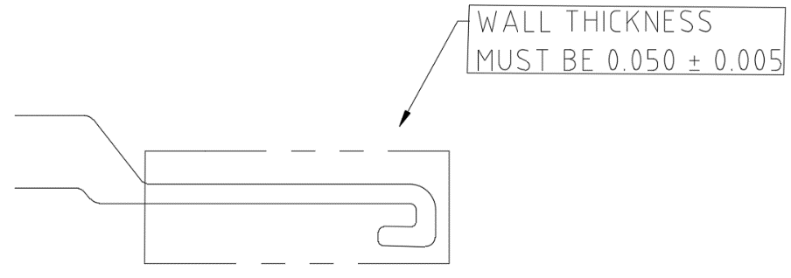
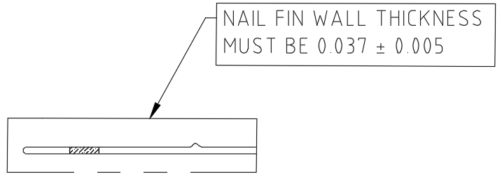

PLEASE CHECK CAREFULLY TO MAINTAIN THIS THICKNESS
DAY SHIFT |  | AFTERNOON SHIFT |  | NIGHT SHIFT
NAME | SIGNATURE | NAME | SIGNATURE | NAME | SIGNATURE

